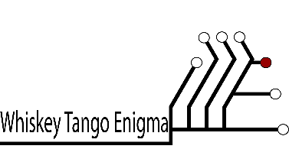

**USER MANUAL**

MIDWESTERN STATE UNIVERSITY

CARD SERVICES

Authors:

Devin Ritter, Andrew McKissick, Tellon Smith, Anderson Nwammadi, Johann Redhead

Product of Whiskey Tango Enigma®

©March 2017 Department of Computer Science, Software Engineering